NAME: Dave Nearing CS466-001
CHAPTER: 5
LAB:

For each chapter, you will complete a set of Animated Flashcards, Book exercises, and Lab exercises. Although you will have three different activities, you will submit them in one document. Use this document to record your answers for submission.

ANIMATED FLASHCARDS

In order to receive any point value for the Book and Lab exercises, you must submit your answers to the chapter’s Animated Flashcards, found on the textbook companion web site. Identify your responses with the Flashcard question numbers in this section.

1. synchronous processing
2. motherboard
3. arithmetic/logic unit (ALU)
4 track
5. instruction register (IR)
6. cylinder
7. input unit
8. sector
9. program counter (PC)
10. output unit
11. seek time
12. register
13. transfer rate
14. addressability

BOOK EXERCISES

Refer to the chapter’s corresponding eLearning module or the course schedule for the assigned chapter exercises. Identify your responses to the exercises by including their numbers as they appear in the chapter in this section.

1. B
2. A
3. C
4. D
5. H
6. G
7. E
8. F
9. G
10. F
11. E
12. D
13. A
14. I
15. E
16. I
17. F
18. A
19. C
20. E
21. B
22. F
23. D
27. You can access it at 130000000 cycles/second
28. 28160
29. Revolutions per minute. It's a measure of how fast data can be accessed on a disk, because the disk can only read when the reading head is over the data you want. The faster the disk spins, the faster it gets to the head, and the faster you can access it.
30. Data and instructions are the same and can be stored in memory, which allows programs to be run on data in memory rather than requiring an operator.
31. Memory is separate from the CPU.
32. memory, I/O units, arithmetic/logic unit, control unit.
33. 256
34. Performs math operations and logic operations.
35. The control unit- it puts the actions of the other units in order.
36. Pros- permanent record/storage, Cons- time consuming to input/output, required an interpreter to read.
37. IR is a register in the control unit that holds the instruction being executed
38. It's a register in the control unit that holds the next instruction to be executed
39. Fetch from program counter, decode, execute.
40. The control unit goes to the address in the program counter, copies it, puts the copy in the instruction register, and then advances the program counter to the next step.
41. Control unit figures out what the instruction is and finds the operands for the instruction in memory if needed.
42. The ALU receives signals which it processes.
43. RAM- random access memory, read/write capable, discarded when there's no power
ROM- Read Only Memory, read-only capable, burned into the chip and cannot be changed (unless you flash it), persists through loss of power

LAB EXERCISES

The Lab Exercises are found on the textbook companion web site by clicking Explorations in Computer Science link, located in the left-side panel. Refer to the chapter’s corresponding eLearning module or the course schedule for the assigned exercises. Identify the Exercise and the activity’s number as you record your responses in this section.

1. 3. There are 4 instructions, not 3.
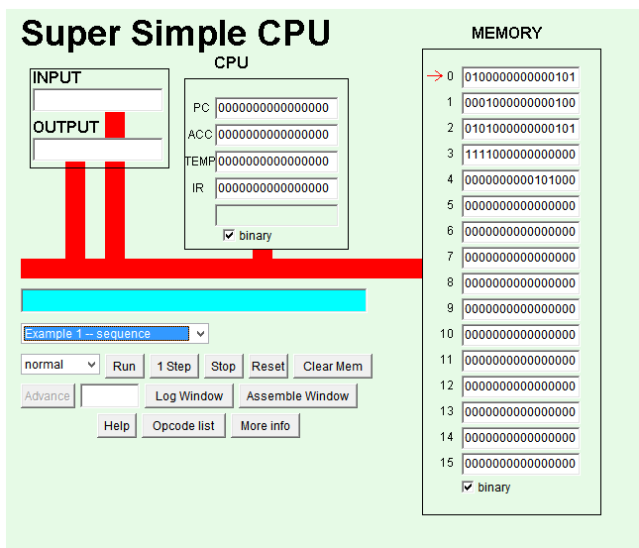
5. LDI, ADD, STO, STP
6. 4

2. 6.
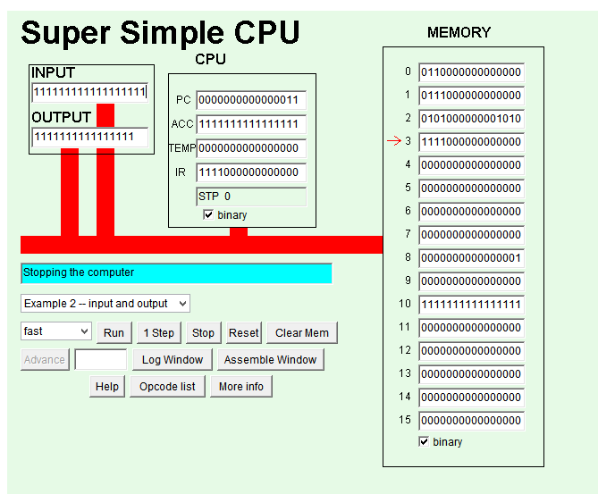

3. 4. LDI 0000000000001110
5. LOD 0000000000010101

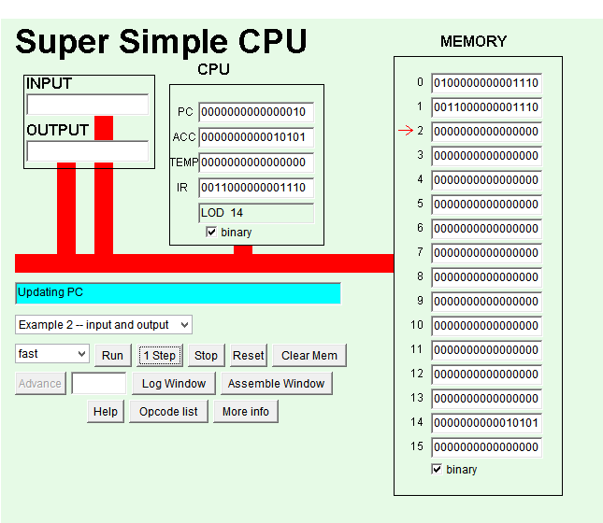
6. LDI loads the next cell, LOD loads a target cell
7. I think it's because there's not enough room in the register for an immediate. That'd require 28 bits (4 for the opcode, 12 for the immediate, 12 for the target location) and you only have 16 to work with.

8. 0100000010000001
0101000000001100
1111000000000000

